To model the tanh activation, we will use a bipolar differential amplifier.

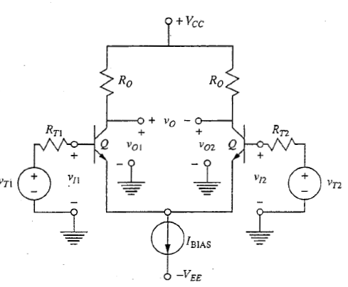

The output of this circuit has the following transfer characteristic (see [] for derivation):

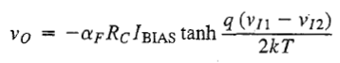

Where $α$ is the transistor’s alpha and $\frac{kT}{q}\sim 0.02586 V$ is the thermal voltage at $T=300K$.

Since we only need one input, we can set $V_{I2}$ to 0 by connecting it to ground. This will lead to:



We would also like to set the scaling term $α_{F}R_{C}I_{BIAS}$ to 1. We obtain $α_{F}$ from the datasheet of the transistor that is used. Then, $R_{C}$ can be set to an arbitrary, but sensible value (e.g. $1kΩ$). The bias current can then be inferred by:

$$I_{BIAS}=\frac{1}{α_{F}R_{C}}$$

For a reason that will become apparent soon, suppose that the input $V_{I1}$ was obtained as follows:

This would cause the following relationship between $V_{IN}$ and $V_{I1}$:

$$V_{I1}=\frac{R_{2}}{R_{1}+R_{2}}V_{IN}$$

If we substitute all modifications we did to (x.x) so far the result would be:

$$V_{O}=-\tanh\left(\frac{q}{2kT}⋅\frac{R_{2}}{R_{1}+R_{2}}V_{IN}\right)$$

To have the correct scaling, we shall set the constant factor in front of $V_{IN}$ to 1. We can do this by first setting $R_{2}$ to an arbitrary but sensible value (e.g. $1kΩ$), and then – with a bit of manipulation – obtain the value of $R_{1}$ using:

$$R_{1}=R_{2}\left(\frac{q}{2kT}-1\right)$$

The eagle-eyed reader might have noticed that there would still be a minus sign left in front of the tanh expression. We will take care of this in a moment. First, we should find a circuit which can generate the constant current $I_{BIAS}$. A possible solution is the Widlar constant current source illustrated below.

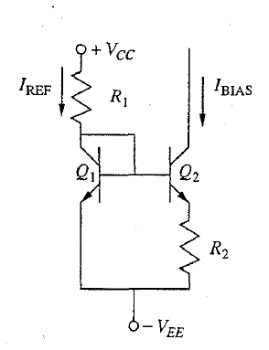

Again, we can set $R_{1}$ to an arbitrary but sensible value (e.g. $10kΩ$) and then calculate the value of $R_{2}$ (see [] for derivation) using:

$$R_{2}=\frac{kT}{qI_{BIAS}}⋅\ln\left(\frac{I_{REF}}{I_{BIAS}}\right) \\ where I_{REF}=\frac{V_{+}+V_{-}+0.6}{R_{1}}$$

We should remind ourselves that $V_{O}$ is not a ground referenced voltage. It is the difference between $V_{O1}$ and $V_{O2}$. To convert the differential voltage to single-ended voltage we can pass these two voltages to a differential input amplifier.

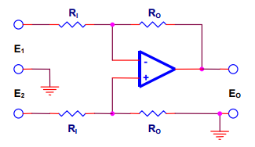

This circuit has the following transfer characteristic (assuming all resistors have the same value):

$$V_{OUT}=V_{O2}-V_{O1}=-V_{O}$$

Remember that minus sign in front of the tanh function from before? We just took care of it by connecting $V_{O1}$ and $V_{O2}$ in the specific order above.

The complete tanh activation then looks like this: